Serviio Media uPnP Issue Not Showing

How do I fix UPnP on my computer?

Method 1

Locate and click the icon for Network and Sharing Center.

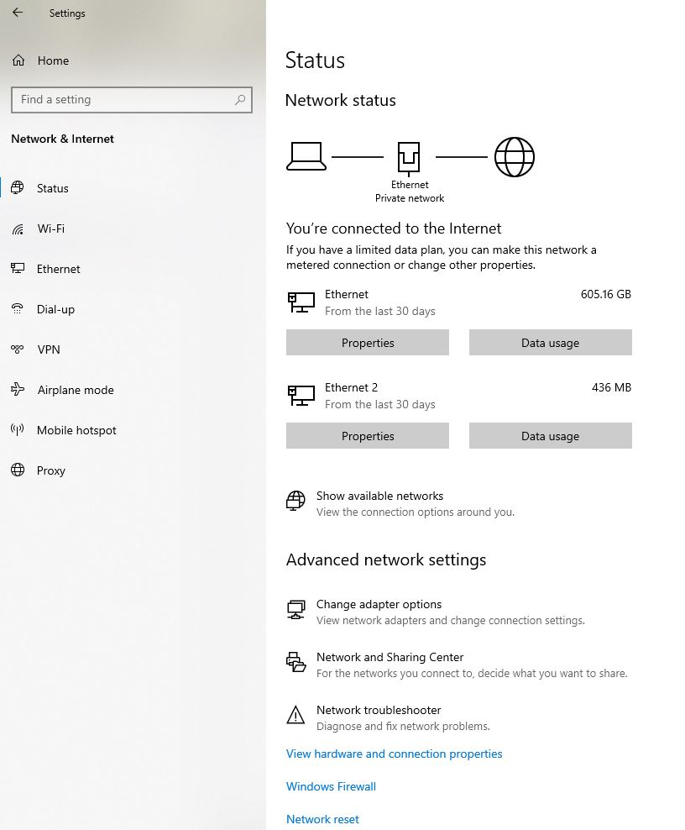

Click on “Media Streaming Options” and enable this option

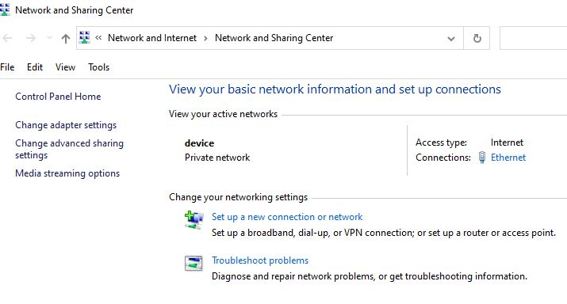

In my case I had to disable the Media Player for my computer so users would not have access to the server that use as my pc also

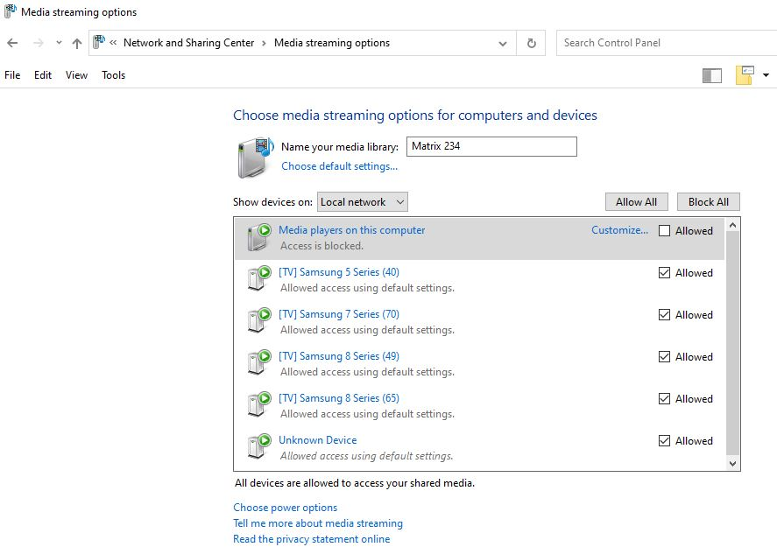

You can click on customize and diable the rated content

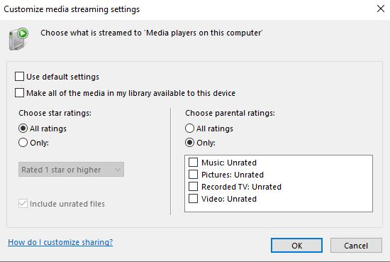

Method 2:
Locate and click the icon for Network and Sharing Center.
In the Sharing and Discovery section, click the arrow button to the right of the Network discovery option. Select the option for Turn on network discovery and click the Apply button. UPnP now automatically start when you turn on your computer.

